**The Scenario**

The problem is that it currently is no study tool to help with learning Latin.

**The Client**

My client is Mrs. Edson, and this program is intended for use by end users who wish to learn Cambridge Latin levels 1 and 2 as well as IB Latin SL.

**Current Solution**

The current solution available to the client is to just read the textbook/class translations of the Latin texts. They would have to re-read the whole section they wish to study, and if they wanted to quiz themselves they have to cover up the information with a hand/piece of paper, see if they can remember it, and then check themselves. The downsides are that this is slow (because the whole section must be re-read rather than a summary) and inconvenient. The advantages of this method are that studying can be done without a computer.

**Sample Data**

Evidence of Consultation: 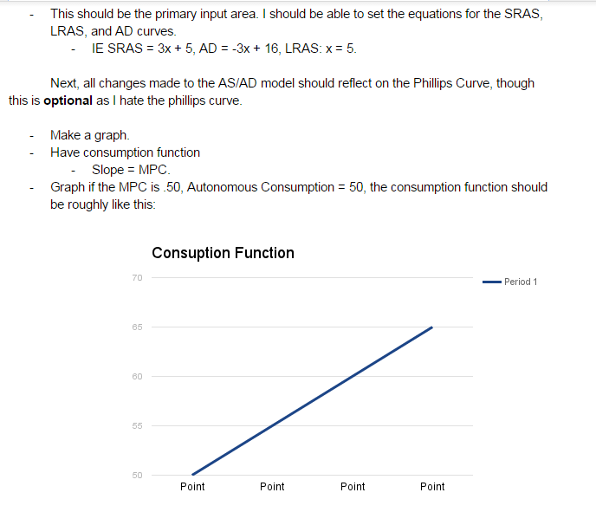

In the first example, 3 would become the slope of SRAS, 5 would become the y intercept. -3 would become AD’s slope; 16 its y intercept. The LRAS would be set to 5.

In the second example, the slope of the consumption line would become .5 and the y intercept would be set to 50. In addition, because these are economic data that are important for other graphs, these would be stored as doubles in the program.

**Analysis of the Program**

The program must be able to display to the screen the relevant information in a succinct and easy-to-understand manor. This means that the program cannot be text only, and that significantly complicates the coding process. The program must also be able to show information piece by piece, so that the client can quiz themselves one question at a time. The program must be able to read from a file so that it can quickly load in the relevant information. The program must also be able to accept input on which sections should be marked for review, and this information should be stored permanently on a file, necessitating writing to a file.

**The Proposed Solution**

The program will allow the user to select which chapter/author they wish to study, and then what they wish to study in that section. The program will then display a summary of that information so that they can study it. The client will also be able to quiz themselves by using a feature that displays questions/information one at a time and allows the user to check themselves. The program will allow the user to mark areas where they were incorrect or feel unconfident so that they know where to go back and review.

**Criteria for Success**

* Essential Features
  + Be able to display a summary of important information for grammar
  + Be able to display the important vocab
  + Be able to show a line by line direct translation of the Latin text
  + Allow users to quiz themselves
* Requested Features
  + Mark areas of weakness to study later
  + Allow users to make own notes/addendums to summaries
  + Have comprehensive end of course review sections
* Optional Features
  + Support for learning the culture section in Cambridge Latin
  + Support for learning poetic devices
  + Allow sending questions to teacher from program
  + Ability to share/export notes
  + Support for extracurricular Latin for competition